
GARISSA UNIVERSITY

UNIVERSITY EXAMINATION 2018/2019 ACADEMIC YEAR TWO
SECOND SEMESTER EXAMINATION

SCHOOL OF INFORMATION SCIENCE AND TECHNOLOGY

FOR THE DEGREE OF BACHELOR OF COMPUTER SCIENCE

COURSE CODE: COM 215

COURSE TITLE: ELECTRICAL CIRCUITS

EXAMINATION DURATION: 2 HOURS

DATE: 0/02/2020 TIME: 0.00-.00 PM

INSTRUCTION TO CANDIDATES

- The examination has FIVE (5) questions
- Question ONE (1) is COMPULSORY
- Choose any other TWO (2) questions from the remaining FOUR (4) questions
- Use sketch diagrams to illustrate your answer whenever necessary
- Do not carry mobile phones or any other written materials in examination room
- Do not write on this paper

This paper consists of SEVEN (7) printed pages please turn over

The following constants may be useful in answering some questions.
Permittivity of free space ℇ_{o} 8.854 x 10⁻¹²C²/Nm² or F/m
Plancks constant (h) 6.62617 x 10⁻³⁴Js
Electronic charge (q) 1.60218 x 10⁻¹⁹C
Speed of light in a vacuum 3.0 x 10¹⁰ cm/s

QUESTION ONE (COMPULSORY)
A. i. Using examples distinguish between passive and unilateral circuit elements [3 marks]
ii. Derive the relationship between coefficient of coupling (K), the inductance (L) and mutual inductance, M. [4 marks]
iii. Prove that the equivalent resistance of two resistors in parallel is the ratio of the product to the sum of individual resistors. [3 marks]

B. i. State the effect of a dielectric. [2 marks]

ii. Plates of a parallel-plate capacitor are 5mm apart and 2m² in area. The plates are in a
vacuum. A potential difference of 10,000V is applied across the capacitor. Compute the capacitance and electric field in the space between them. [5 marks]

C. i. Define admittance and state its SI unit. [2 marks]

ii. Name and explain four basic properties or characteristics associated with AC wave
forms. [4 marks]
iii. In the circuit below (fig. 1) compute the effective resistance, R_{EQ}. [5 marks]
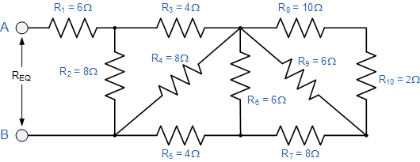
Fig.1
D. Discuss how you would assess the response of circuits to a sinusoidal signal [2 marks]

QUESTION TWO
A. i. State Norton’s theorem and application [2 marks]
ii. Find the Norton equivalent circuit for the network external to the R_{L} = 12Ω resistor in fig. 2 below given that r₁ = 3Ω, r₂ = 4Ω, r₃ = 6Ω and Vs = 9V [8 marks]
Fig.2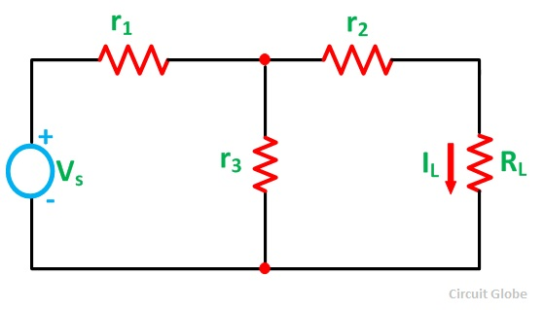
B. i. Find the equivalent inductance for the circuit below. [5 marks]
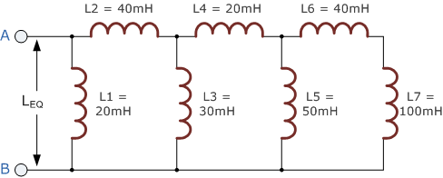
Fig.3
ii. State the disadvantages of Mesh analysis. [1 mark]
iii. Consider the circuit below find the voltage across the 12A current source using mesh analysis [4 marks]
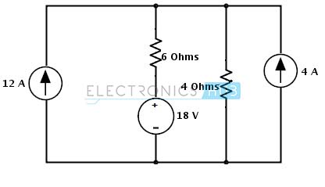
Fig. 4
QUESTION THREE
A. i. Define phasors and their use in resistive, inductive and capacitive circuit [2 marks]
ii. Electrical machines and generators generate the sinusoidal wave below fig.5 of the form V(t) = V_{o}Sin(ω_{o}t + $θ$) . Compute the RMS voltage and angular velocity if the wave oscillates at 50 cycles per second [4 marks]
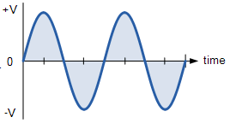Fig.5
B. i. State Maximum power transfer theorem and application. [2 marks]
ii. Consider the circuit below. Determine the value of load resistance, R_{L} and maximum power from the source to load. [6 marks]

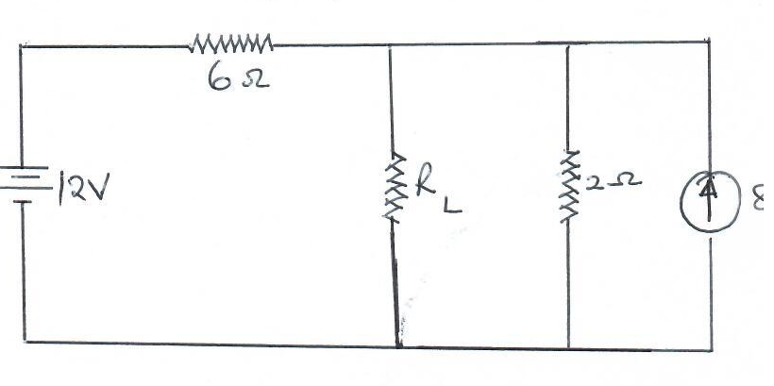Fig.5

C. i). Enumerate three factors affecting the capacitance of a capacitor. [3 marks]
ii). In the circuit below find the equivalent capacitance in circuit below and energy dissipated if its connected across a 12v power supply. [3 marks]
Fig.6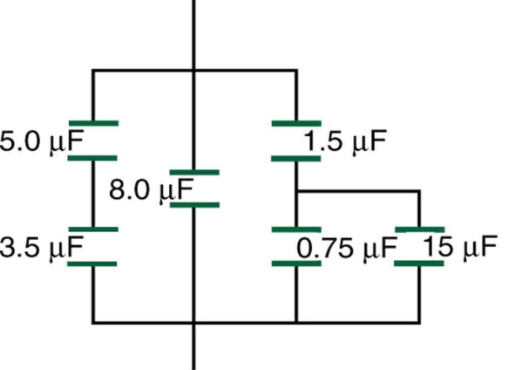

QUESTION FOUR
A. i. State Kirchhoff’s application of point and loop rules. [2 marks]
ii. In the circuit below find the unknown current I, resistance R and EMF using Kirchhoff’s laws. [6 marks]
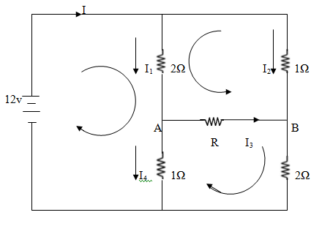
fig.7
B. i. Identify any two protection devices in a circuit. [2 marks]
ii. Name the resistor below and compute its rating. [3 marks]
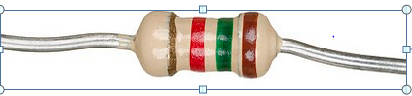 Fig. 8
C. Nodal analysis provides a general procedure of analyzing circuits using node voltages. Basing on this theory find the voltage at each node of this circuit [7 marks] 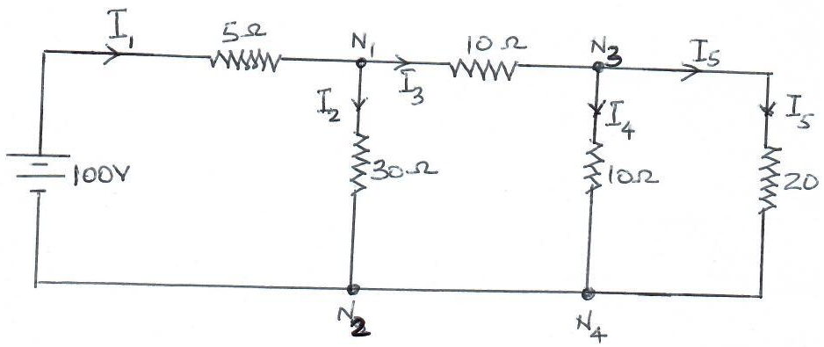Fig.9

QUESTION FIVE
A. i. State Superposition theorem and elaborate what is meant by “setting the current
Source to zero amperes” [2 marks]
ii. Using the Superposition theorem determine current through the 12Ω resistor and demonstrate Superposition theorem is not applicable to power levels. [10 marks]

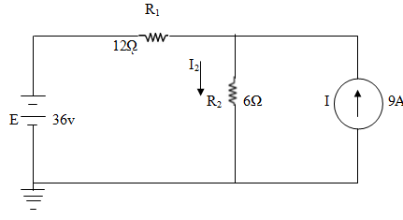 Fig,10
B. i. Explain the uses of applying Thevenins theorem in circuit analysis. [3 marks]
ii. Find the Thevenin equivalent circuit for the network below. Then find the current
through R_{L} for values of 2Ω and 10Ω. [5 marks]
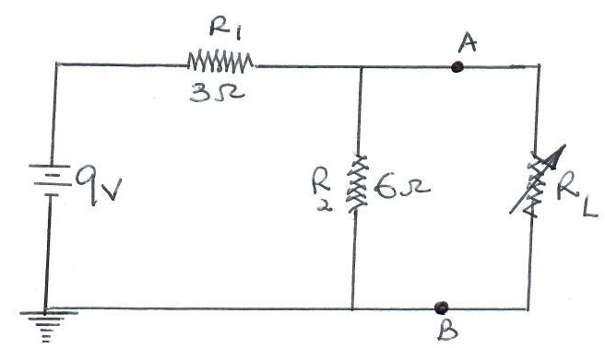
Fig.11

