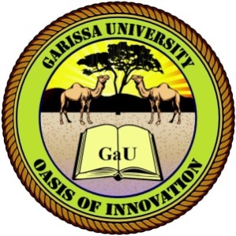

**GARISSA UNIVERSITY**

**UNIVERSITY EXAMINATIONS**

**2020/2021 ACADEMIC YEAR**

**FOURTH YEAR SECOND SEMESTER EXAMINATION FOR BACHELOR OF EDUCATION (ARTS)**

**SCHOOL OF ARTS AND SOCIAL SCIENCES**

**COURSE CODE: REL 423**

**COURSE TITLE: YOUTH AND RELIGION**

**EXAMINATION DURATION: 2 HOURS**

**MODE OF STUDY: SCHOOL-BASED**

**DATE: TIME:**

**INSTRUCTIONS TO CANDIDATES**

1. **This examination has FIVE (5) questions.**
2. **Question ONE (1) is COMPULSORY.**
3. **Answer any TWO (2) other questions from the remaining FOUR (4).**
4. **Use diagrams to illustrate your answers whenever necessary.**
5. **Do not carry mobile phones or any other written materials into the examination room.**
6. **Do not write on this paper.**

**This paper consists of Two (2) printed pages Please turn over**

**QUESTION ONE (COMPULSORY)**

1. Explain any two factors behind sociological interests in the study of young people’s religion (5 marks)
2. Identify five important ways through which the youth enhances the life of any given religion and society (10 marks)
3. Elucidate any five challenges of contemporary world on the African youth while clearly indicating the contribution of religion towards addressing them (15 marks)

**QUESTION TWO**

1. Identify any five positive and negative impact of religion on youth (10 marks)
2. Elucidate any five factors that must be considered in building up a good rapport (10 marks)

**QUESTION THREE**

1. Briefly explain five reasons for the young people’s attraction to New Religions Movements/Cults. (10 marks)
2. Highlight five factors each for increase and decrease of religious commitment among the adolescents/youth. (10 marks)

**QUESTION FOUR**

1. Explain the meaning of youth ministry while identifying at least six important features that should be integrated into successful programs for youths (14 marks)
2. Give six points in justification of youths’ participation in youth ministry (6 marks)

**QUESTION FIVE**

1. Explain the consequences of sidelining the youth in religious activities (12 marks)
2. Identify any one Christian and one Islamic youth movement while clearly explaining their objective with regard to ‘youth and religion’ (8 marks)