
UNIVERSITY EXAMINATION 2020/2021 ACADEMIC YEAR
SECOND SEMESTER EXAMINATION
SCHOOL OF PURE AND APPLIED SCIENCES
DEPARTMENT OF NATURAL SCIENCES
COURSE CODE: CHE 122
COURSE TITLE: ORGANIC CHEMISTRY I
EXAMINATION DURATION: 3 HOURS
TIME:
DATE:

INSTRUCTIONS TO CANDIDATES
- The examination has Five (5) Questions
- Question one (1) is COMPULSORY
- Choose any other Two (2) Questions from the remaining Four (4) Questions

QUESTION ONE (1) – COMPULSORY (30 marks)

- What are the hybridizations of atoms 1 and 2 respectively in the following structures? (5 Marks)
1) 2) 3)

- Using IUPAC nomenclature name of the following organic compounds (3 Marks)

1) 2) 3)
- Explain and write Wurtz reaction for preparation of alkanes? (3 Marks)
- Explain why Boiling points of isomeric alkanes goes on decreasing with increased branching? (2 Marks)
- Why do alkenes undergo electrophilic addition and not electrophilic substitution reaction? (2 Marks)
- Explain why Alkynes do not exhibit geometrical isomerism while alkenes do so?
(2 Marks)
- Explain why alkenes undergo addition and not substitution reaction? (3 Marks)
- Why does benzene undergo electrophilic substitutions reactions easily and nucleophilic substitutions with difficulty? (3 Marks)
- Explain why Solubility of alcohols in water decreases with increase in molecular mass of the alcohol? (2 Marks)
- Why do Carbonyl compounds mainly show nucleophilic addition reactions?
(2 Marks)
- How can you distinguish an alcohol and a carboxylic acid? (3 Marks)

QUESTION TWO (2) (20 marks)
- Give two methods for the preparation of alcohols and give chemical equation for each preparation (4 Marks)
- Why amines have lower boiling points than those of alcohols or carboxylic acids?
(3 marks)
- Describe why the boiling point of an alkyl halide is higher than that of corresponding alkane? (2 marks)
- Why do aldehydes and ketones have high dipole moments? (3 marks)
- Why do amines react as nucleophiles? (2 marks)
- Name the following organic compounds using IUPAC nomenclature? (6 marks)
1) CH₃CONH₂ 2) 3)

QUESTION THREE (3) (20 marks)
- Name the classes of compound that the following molecules belong to (E.g. alkane, amide, etc). (10 marks)
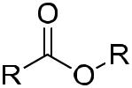
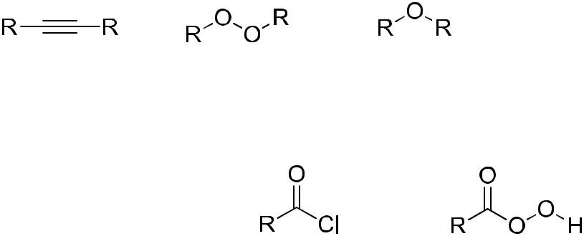

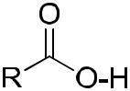
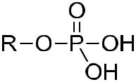

- Explain the mechanism of the following addition reactions (including curve arrows) (10 Marks)
CH₃ CH₃ CH₃ CH₃
C C + H-Cl H Cl
CH₃ CH₃ CH₃ CH₃

QUESTION FOUR (4) (15 marks)
- Write the major product of the following reactions (10 marks)

1.)

2.) 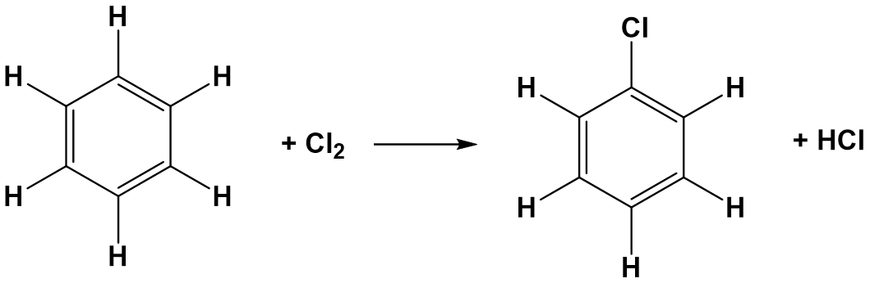
- Draw and name two molecules that are structural isomers (5 marks )
- Name two methods of preparation of carboxylic acids giving chemical reactions for each. [5 marks]
QUESTION FIVE (5) (20 marks)
- For the following molecule, calculate the number of (7 marks)
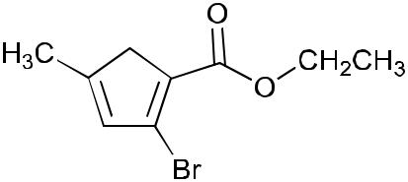
- carbon atoms
- π bonds
- sp² hybridized carbons
- sp hybridized atoms
- lone pairs (non bonding pairs) of electrons
- the C-O-C bond angle
- carbons in the ring

- Met-enkephalin, an endorphin serves as natural pain reliever that changes or removes the perception of nerve signals, label all functional groups present in the structure below of met-enkephalin? (8 marks)

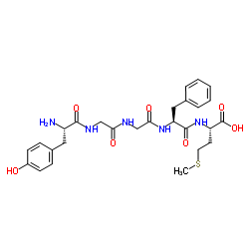
- Explain the mechanism and the product of the addition reaction below? (5 marks)

H₂C=CHCH₂CH₃ +H₂0 ?

