

**GARISSA UNIVERSITY**

**SCHOOL OF PURE AND APPLIED SCIENCES**

**ACADEMIC YEAR 2020/2021**

**UNIVERSITY EXAMINATION**

**SECOND YEAR SPECIAL/SUPPLEMENTARY EXAMS ACADEMIC YEAR 2020/2021**

**FOR THE DEGREE OF BACHELOR SCIENCE(EDUCATION)**

COURSE CODE: PHY 121

COURSE TITLE: Geometric Optics

**EXAMINATION DURATION: 2 HOURS**

**DATE:……….. TIME:**

**INSTRUCTIONS TO CANDIDATES**

* **The examination has six(5) questions**
* **Question ONE(1) is compulsory**
* **Choose any two (2) questions from the remaining FOUR questions**
* **Use sketch diagrams to illustrate your answer wherever necessary**
* **DO NOT carry mobile phones or any other written materials in examination room**
* **Do not write on this paper**

**QUESTION ONE**

1. What is the maximum magnification that is possible with a lens having a focal length of 10 cm, and what is the magnification of this lens when the eye is relaxed? (4 mrks)
2. An anti-shoplifting mirror shows an image of a woman who is located 3.0 m from the mirror. The focal length of the mirror is -0.25 m. Find
3. the position of her image (5mrks)
4. the magnification of the image (4mrks)
5. A light beam passes from medium 1 to medium 2, with the latter medium being a thick slab of material whose index of refraction is *n*2 (Figure 1). Show that the beam emerging into medium 1 from the other side is parallel to the incident beam (4mrks)

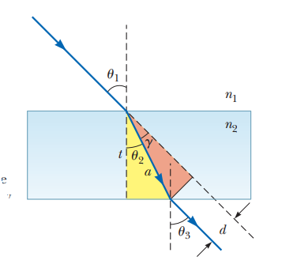

Figure 1: Thedashed line drawn parallel to the raycoming out the bottom of the slabrepresents the path the light wouldtake were the slab not there

1. A small fish is swimming at a depth *d* below the surface of a pond (Figure 2)

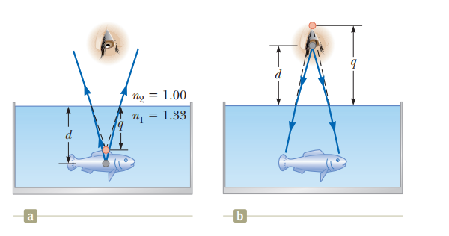

Figure 2: Example 36.7) (a) The apparent depth q of the fish is less than the true depth d. All rays are assumed to be paraxial. (b) Your face appears to the fish to be higher above the surface than it is.

1. What is the apparent depth of the fish as viewed from directly overhead? (3mrks)
2. If your face is a distance *d* above the water surface, at what apparent distance above the surface does the fish see your face? (3 mrks)
3. What if you look more carefully at the fish and measure its apparent *height* from its upper fin to its lower fin? Is the apparent height *h*’ of the fish different from the actual height *h*? (4 mrks)
4. An automobile rearview mirror shows an image of a truck located 10.0 m from the mirror. The focal length of the mirror is 20.60 m.Find the position of the image of the truck (3 mrks)

**QUESTION TWO**

1. Consider light rays’ incident on a glass prism (Figure 3), using a well labeled diagram, derive an expression for the index of refraction of the prism material. (10mrks)

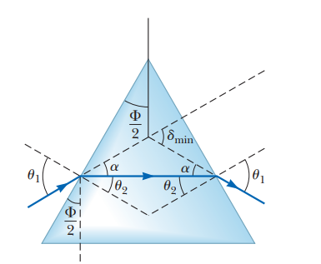

Figure 3: A light ray passing through a prism at the minimum angle of deviation $δ_{min}$.

1. State the Huygens’s principle and use it to prove the law of reflection and the Snell’s law (10mrks)

**QUESTION THREE**

1. **Describe** Roemer’s Method and Fizeau’s Method (8mrks)
2. Two thin converging lenses of focal lengths *f*1 = 10.0 cm and *f*2 = 20.0 cm are separated by 20.0 cm, as shown below. An object is placed 30.0 cm to the left of lens 1. Find the position and the magnification of the final image (9 mrks)

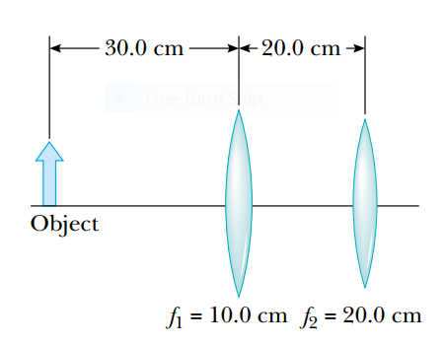

1. The lens of a certain 35-mm camera (where 35 mm is the width of the film strip) has a focal length of 55 mm and a speed (an *f* -number) of *f*/1.8. The correct exposure time for this speed under certain conditions is known to be (1/500) s. Determine the diameter of the lens.(3mrks)

**QUESTION FOUR**

1. A diverging lens has a focal length of 10.0 cm.
2. An object is placed 30.0 cm from the lens. Construct a ray diagram, find the image distance, and describe the image (6mrks)
3. An object is placed 10.0 cm from the lens. By analysis, find the image distance, and describe the image (4mrks)
4. An object is placed 5.00 cm from the lens. By analysis, find the image distance, and describe the image (4mrks)
5. Explain the following:
6. Spherical Aberrations (2mrks)
7. Chromatic Aberrations (2mrks)
8. angular magnification (2mrks)

**QUESTION FIVE**

1. Explain how the telescope works (4 mrks)
2. State the Huygens’ Principle (1mrk)
3. Use Huygens’ Principle to prove the Snell’s law (6mrks)
4. Show that the minimum magnification of a simple magnifier can be expressed as $m_{min}=\frac{θ}{θ_{0}}=\frac{25cm}{f}$ (7mrks)
5. Explain the wave-particle nature of light (2mrks)