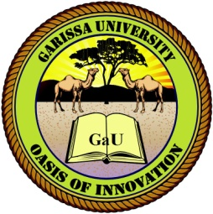
GARISSA UNIVERSITY
UNIVERSITY EXAMINATION 2020/201 ACADEMIC YEAR ONE
SECOND SEMESTER EXAMINATION

SCHOOL OF SCHOOL OF PURE AND APPLIED SCIENCES
DIPLOMA IN INFORMATION TECHNOLOGY

COURSE CODE:

COURSE TITLE:

EXAMINATION DURATION: 2 HOURS

DATE: /08/2021 TIME: 02.00-05.00 APM

INSTRUCTION TO CANDIDATES

- The examination has FIVE (5) questions
- Question ONE (1) is COMPULSORY
- Choose any other TWO (2) questions from the remaining FOUR (4) questions
- Use sketch diagrams to illustrate your answer whenever necessary
- Do not carry mobile phones or any other written materials in examination room
- Do not write on this paper

This paper consists of TWO (2) printed pages please turn over

QUESTION ONE (COMPULSORY)

