DIT 028 - Digital Electronics

End of semester exams JAugust, 2021

**Section A: Compulsory**

**Question 1**:

1. Define
2. intrinsic and
3. extrinsic semiconductors. (4mks)
4. Explain the following terms: (3mks)
5. Conductor
6. Insulator
7. Semiconductor

c. Highlight six characteristics of semiconductors. (6mks)

d. Briefly describe how you can obtain a P-N junction using a well-illustrated diagram. (5mks)

e. what is doping (2mks)

f. Drawthe p-n junction diode symbols for both forward and reverse bias. (5mks)

**Section B:**

* Choose three questions,
* All questions carry equal marks

**Question 2**

a. Define the term transistor. (2mks)

b. A common emitter transistor has a reverse leakage current, ICBO =48Na and a gain α= 0.992.

* Find β and ICEO (4mks)
* Find its exact collector current when IB =30µA. (4mks)
* Find the approximate collector current neglecting leakage current. (2mks)

c. State the three types of transistor static characteristics. (3mks)

**Question 3**

a. Work out as indicated in brackets.

* (1001.0101)2 (**Binary –to- decimal conversion)** (3mks)
* (1E0.2A)16 (**Hexadecimal – to – decimal conversion** (4mks)

b. State any two (2) advantages of digital systems. (2mks)

c. Convert the following binary numberto its decimal equivalent. (3mks)

(1001.0101)

d. Express the following binary number into their 2’s complement. (3mks)

10010110

**Question 4**

a. What do you understand by the term;

1. ‘Quiescent point’
2. Logic gate (3mks)

b. State the four transistor biasing methods. (4mks)

c. compute the two’s complement of the following binary numbers.

* 10010110 (4mks)
* 10001001 (4mks)

**Question 5:**

a. Complete the truth tables below for the basic operators indicated. (6mks)

**AND**

|  |  |  |
| --- | --- | --- |
| **A** | **B** | **R** |
| 0 | 0 |  |
| 0 | 1 |  |
| 1 | 0 |  |
| 1 | 1 |  |

OR +

|  |  |  |
| --- | --- | --- |
| A | B | R |
| 0 | 0 |  |
|  | 1 | 1 |
| 1 | 0 |  |
| 1 |  | 1 |

NOT ‘

|  |  |
| --- | --- |
| A | R |
|  | 1 |
| 1 |  |

b. simplify the following Boolean expression using DeMorgans’ theorem (5mks)

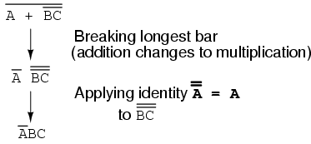

c. Represent the simplified expression in a circuit diagram. (4mks)

**Question 6:**

a. Convert the following binary number to their hexadecimal equivalents. (3mks)

1001.1111

b. Perform the following binary operations (6mks)

1. 00010011 + 00111110
2. (b) 00110011 – 00010110
3. (c) 00101001 x 00000110

c. Providelogical expressions **D**, **E** &**Q** for the arrangement below. (6mks)

[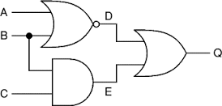](https://www.google.com/imgres?imgurl=http://boncoeur.be/logic_gates/gates1.gif&imgrefurl=http://boncoeur.be/logic_gates.html&docid=YjZf26AFAjKe2M&tbnid=Ng8qqZXgOjmyfM:&w=343&h=164&client=firefox-a&bih=624&biw=980&ved=0ahUKEwi4tNS8lNnNAhXLVRQKHerCCZgQMwhlKCgwKA&iact=mrc&uact=8)